Project Design Phase-II
Data Flow Diagram & User Stories

Date | 30 September 2026
Team ID | SWTID-2026-6284
Project Name | AI WEATHER WISE
Maximum Marks | 4 Marks

- Data Flow Diagrams
In *AI Weather Wise API*, Data Flow Diagrams (DFDs) illustrate the systematic flow of data within the system.

- *Level-0 (Context Diagram)* shows the overall system where the user sends a location request and receives an AI-predicted weather forecast.

- *Level-1* breaks down the system into key processes: 1. Process User Request, 2. Fetch Weather Data from external sources like Open Weather, 3. AI Prediction Engine for enrichment, and 4. Generate Forecast.

- *Level-2* further details validation, data preprocessing, model inference, database storage in Weather Database, and API response generation, ensuring accurate, secure, and smooth weather information delivery.
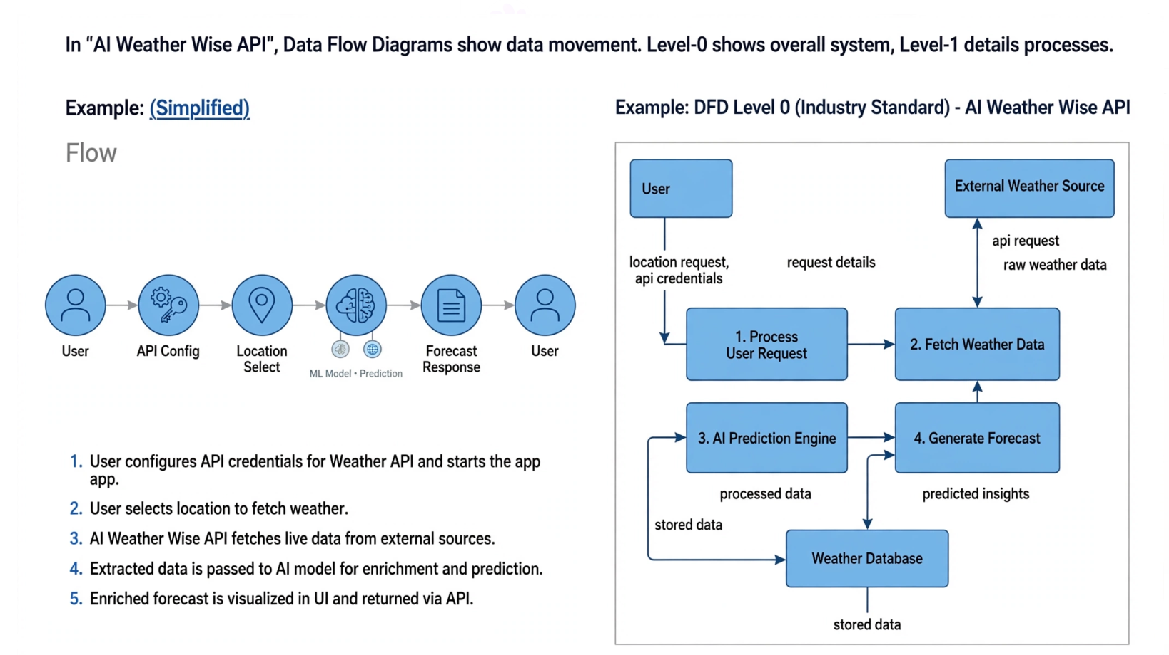
- User Stories
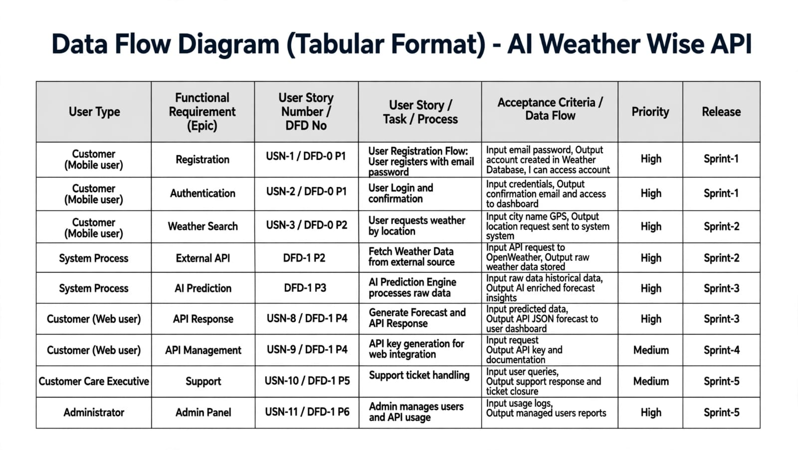
User Stuuuuuuuusuuuuuuuuuuuuuuuuuuuuuuuuuuuuuuu

